L U M S D E N S C H O O L
Newsletter Issue 24 – August 19th 2016

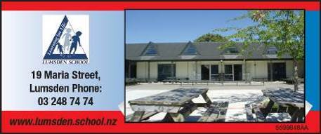

Contents
Page 1
- Principal’s Letter

Page 2
- Looking Ahead 2016
- Paid Union Meeting Day
- FoLS Update

Page 3
- VIP of the Week
- House Sheild Changes Hands
- Ball Skills
- What I like about New Zealand … (Room 1)

Page 4
- Clown Stories – Room 4
- 9th and 12th Grade Lumsden Wasps Football teams: Home game!
- Northern Southland Amateur Swimming Club
- Jo Seager – East Gore School Fundraiser

NEWSLETTERS

Please

- Look for it on a Friday afternoon

- Take note of anything needing attention

- Return slips as soon as possible

Dear School Friends and Families

Good to see some golden moments for Kiwi competitors
at the Olympics this week. Also the huge sporting gesture
by Nikki Hamblin on the running track, helping her injured
fellow competitor. It certainly brought into focus the
Olympic spirit, which runs much deeper than winning.

We’re enjoying some games of our own at the moment during daily fitness. The children have been playing traditional māori games, and while there are no medals at stake, it’s good to see the teamwork and co-operation that’s been going on.

Everything is in place now for Ski/Gore trips… Hoping for some ‘Remarkable’ weather on the day! You’ll have received final information today, including transport arrangements. We are extremely appreciative of all the offers of transport we received. A reminder that it is mandatory for all children to be in safety standard approved car seats until their 7th birthday. Parents of these children not transporting them will need to ensure that car seats are dropped off at school prior to
trip departure. These car seats will need to have the
children’s name on them (E.g. a taped or sticky
label. It is also recommended that children over 7 years
old who are under 148cm tall be in a booster seat –
Likewise, please send a named booster seat if you wish
to comply with this recommendation.

Well done to Rachael Miller and Kynan Marsh who
competed in the Mid Dome speech contest on Wednesday.
Congratulations to Rachael, who was second, and has
qualified through to the next round at Otautau with her
excellent speech about Dr Zeuss. All of the eight speeches,
including Kynan’s ‘Martin Luther King’ speech, were of a
very high standard.

It was great to see all the support we had for our 50¢ book sale recently. The final proceeds came to approximately $120 to put towards new up to date non-fiction books.

Please see over for information regarding a Teachers Paid Union Meeting on September 7. Buses will be leaving for home at 12:30 pm across our transport network that day. Although the school will be officially open, we’re hoping for parents’ support in enabling children to come home at this earlier time, as staff will be attending this meeting in Gore. We would be able to provide supervision for a small number of children only, for families who would find the early home-coming too difficult, however, they would need to be picked up at the normal bus departure time.

Finally, my grateful thanks to Annabel Saunders, Carrie
Adams, and Ngaire Dittmer who have stepped down from
their respective Friends of Lumsden School (FoLS)
chairperson, secretary, and treasurer positions, having all
contributed much in these roles (See over for more FoLS news).

Have a good weekend. Ka kite ano,

Andrew Watson
Principal

Thur




Reminder: text follow lumsdenschool to 8987 so that you will receive immediate text notification of alerts and reminders via our twitter account (e.g. snow days, cancellations).

Reminder:
All Ski / Ice Skating payments need to be made on Monday please – thanks to those families who have already paid



Looking Ahead 2016
Monday | Tuesday | Wednesday | Thursday | Friday | Saturday | Sunday
22 | 23 Eileen Ryan PHN here | 24 Ski/Skating Trip | 25 | 26 | 27 | 28
29 Polyfest, Invercargill | 30 | 31 | 1 Sept | 2 | 3 | 4
5 | 6 St John in Schools | 7 Teachers Paid Union meeting, buses leave school at 12.30 pm | 8 | 9 FoLS Coffee and Catch up 1.45 pm | 10 | 11
12 | 13 BOT Meeting; Eileen Ryan PHN here | 14 | 15 | 16 | 17 | 18
19 School Photos | 20 | 21 | 22 Production | 23 End of Term 3 | 24 | 25

Paid Union Meeting Day
On Wednesday 7 September PPTA (Post Primary Teachers' Association) and NZEI (NZ Educational Institute) have called a joint paid union meeting for all its members from 1:30pm in Gore. These two unions cover both primary and secondary teachers and support staff. It is unusual for the two unions to join meetings in this way. They have called this action because of the potential impact the governments proposed changes to the ways schools are funded could have on the way schools operate. Meetings are occuring nation wide. The Principals from Balfour, Lumsden, Mossburn and Northern Southland College have agreed that buses on this day will leave schools at 12:30pm. By law schools are required to stay open for instruction. If you wish for child to remain at school and be supervised until the usual finishing time then please contact us here at school. You will need to organise alternative transport home if this is the case.

Please free to contact me if you have any concerns.

Yours
Andrew Watson
FoLS Update
Thanks to all who attended the FoLS meeting this week. Mr Watson has set the bar high with the yummy treats he brought! There was a good discussion and refresher about the importance of FoLS and its goals. At its essence, FoLS is intended to foster cooperation between parents, teachers and the community and encourage social interaction between these groups. Fundraising for specific purposes and grounds maintenance overlap with the main goals of cooperation and social interaction.

Congratulations to the following new and returning office bearers:
Chair: Jan McFadzien
Vice-Chair: Holly McBride
Secretary: Bex Ware
Treasurer: Belinda McKain
Grants: Jeanna Rodgers

We are looking for someone to take on the lawnmowing roster role. This is not a big job and involves indicating in the newsletter what family is next on the roster and also ensuring that there is fuel for the mower. It would be ideal for this person to live in or handy to Lumsden. Please contact the school if you are able to help with this.
----------------------------------------------------
School Calf Fundraiser: Please consider donating 1 or more Friesian or Jersey Bull calves to the school Calf Fundraiser this year. For more information contact Jan McFadzien 021 060 3396 or leave a message at school office.

VIP of the Week
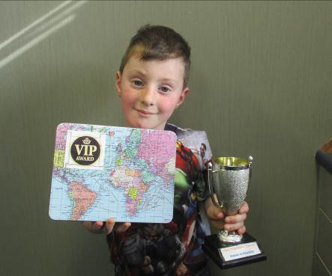

Congratulations to Linn Clark last week’s VIP recipient for caring for someone who was hurt in the playground at lunchtime.

House Shield Changes Hands
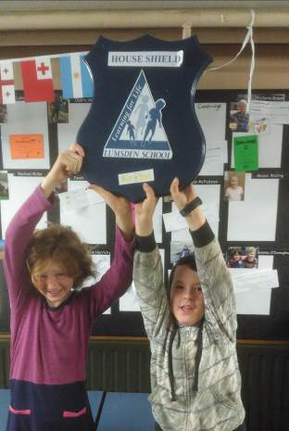

Izzy and Valen, Kowhai House Captains, hold the shield aloft following Kowhai’s win in the House Maths week competition last week. Great to see the fantastic flurry of maths problem-solving activity going on!

Ball Skills
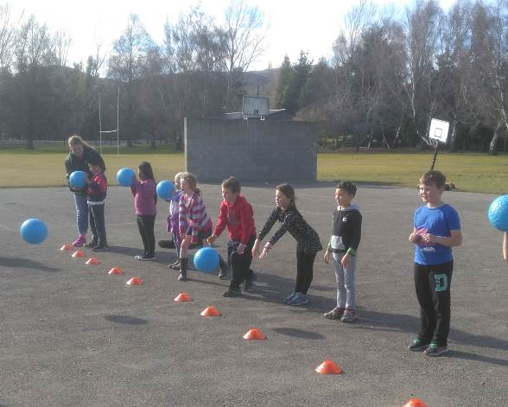

Room 5 during their ball skills session this week, with the guidance of Coaching expert Paulette Leach.

What I like about New Zealand … (Room 1)

I like mountains. They are beautiful.
By Shreesti

I like going to school. I like learning.
By Elizabeth

I love the rivers because they are beautiful.
By Parker

I like New Zealand. It’s fun to ride my bike.
By Saige

Clown Stories – Room 4
I have a clown and my clown is silly because his name is Silly Clown and my clown makes people laugh. Every morning he gets straight up to make the people laugh. Because of him all of the people are happy.
By Grace

My clown is called Silly because he makes people laugh. He is funny when he walks down the road. His name is Angus the Juggler. He has baggy pants. My clown has a house and he shouts and makes people have sore ears.
By Angus

My clown is called Awesome Clown. He makes people laugh. My clown can laugh too. He can laugh so loud he can make the people have sore ears. He juggles too many balls and they fall down.
By Lachie

My clown is called Lucy. I sleep with her. She has a noisy horn. She wakes people up. I push her out of my bed at night. Then I stand on her. She laughs at people too.
By Amelia

I have a clown. He has a red nose. It is red and green. He has claws and they are sharp. He is spectacular at making people laugh. He has a clown family. He has a dot on his head. He has a flower on his hat. My clown has baggy pants. Every morning he gets up to mischief. He is hungry all of the time.
By George

9th and 12th Grade Lumsden Wasps Football teams: Home game!
Both home games kick off at 10:30am at the Lumsden Recreation Grounds. Food (including hot) and drinks available so bring coinage and funds go towards the soccer goals. We would love to have as many supporters as possible and our colours are yellow/gold and black.

Northern Southland Amateur Swimming club will, once again, be offering swimming lessons and squad training sessions in the Lumsden pool for term 4. Please contact nsasc.lumsden@gmail.com for further details.



